Relational and Logical Operators:-

Q 1]

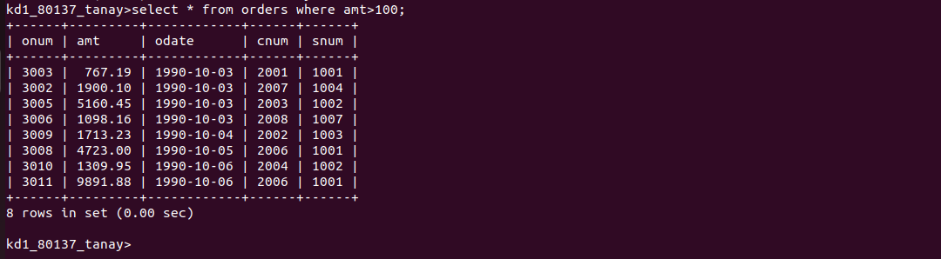

Q 2]



Q 3]



Q 4]
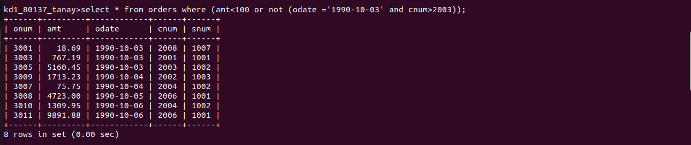

Q 5]

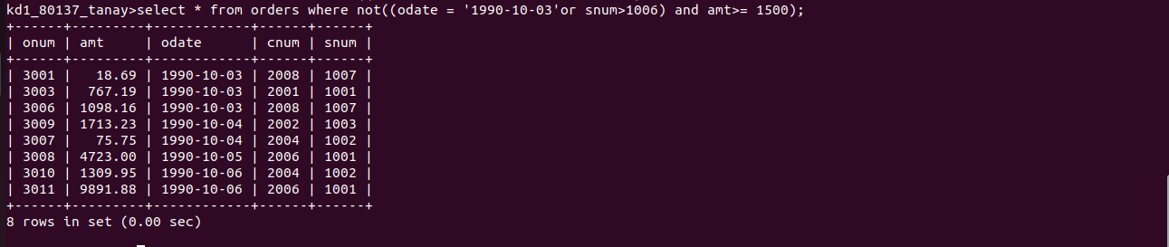

Q 6]



